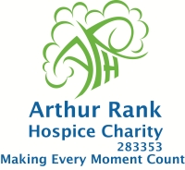 

**The Lisa Barnes Memorial Fund**

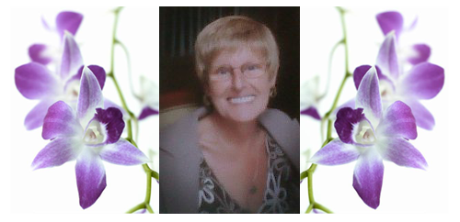

**In Aid of Arthur Rank Hospice**

**Charity**

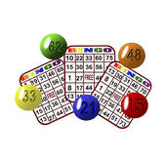

*Cash & Prize Bingo*

*At*

*The Brook, Brook Street Soham*

*13 June 2011*

*Doors open 7pm*

*Eyes down for 8pm*

*Raffle*