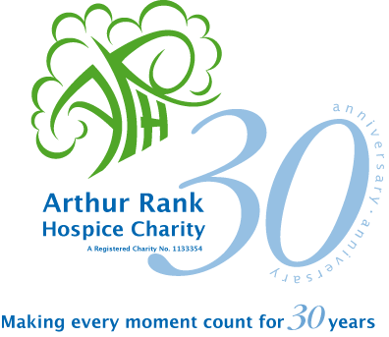 

The Lisa Barnes Memorial Fund

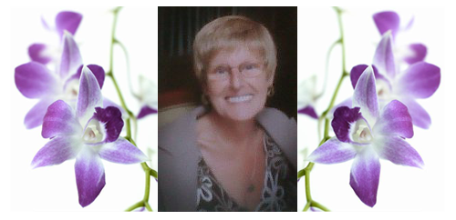

In Aid of Arthur Rank Hospice

Charity

**Fun Dog Show**



Saturday 28 May 2011

Car Park will be open from 10.30am

Dog Show begins at 11.30am

18 CLASSES- £1 per class including

**Best AV Sporting Best AV Non-Sporting Best AV Puppy Best AV Short Hair Scurry Best AV Rescue**

**Best Visitor – more than 20 miles Best Local – less than 20 miles**

**Come and try it – fly ball – fun agility**

**Best Child handling Best Handsome Dog**

Alan’s Ark & Charlie’s Dog Training Centre Northfield Rd Soham CB7 5UF

Refreshment available all day